Welcome!
Date
Name
Spouse
Address
City
State Zip _________
Email

Please Contact By
❑ Card  Phone  Visit

Telephone Best Time to Call
Home ______________
Work ______________

Guest: First Time Second Time
Are you a church member: yes no
Church
City, State

Circle Appropriate Age/Grade Group(s)
Preschool: Ages: B-1 2-3 4-5
Children: Grades: K 1 2 3 4 5 6
Youth: Grades: 7 8 9 10 11 12
Adults: Ages:18-29 30s 40s 50s 60s+

How did you learn about our church?
Newspaper Friend Yellow Pages Mail
Other

I am a guest of:

New in the Community? Yes No
Names & ages of children at home

Weekly Service & Activity Schedule

November 23, 2014
9:45 a.m. Sunday School
11:00 a.m. Morning Worship Service
5:00 p.m. Thanksgiving Basket Packing
6:00 p.m. Evening Worship

Week of November 23
There will be no Adult Bible Study Wednesday Night
There will be no Youth Bible Study Wednesday night

Upcoming Events
December
1 – 6……………..Week of Prayer for Lottie Moon Missions
7…………………………………….…………….Kids In Action
14…………………………..…Children’s Christmas Program
31…………………….……….New Year’s Eve Watch Party

Church committees for the New Year will need to meet as
soon as possible, choose a Committee Chair, and begin
planning for the upcoming year.

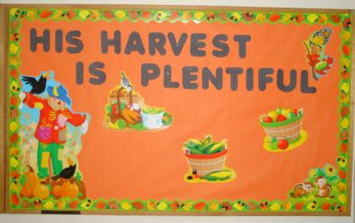

Knobbs Springs Baptist Church
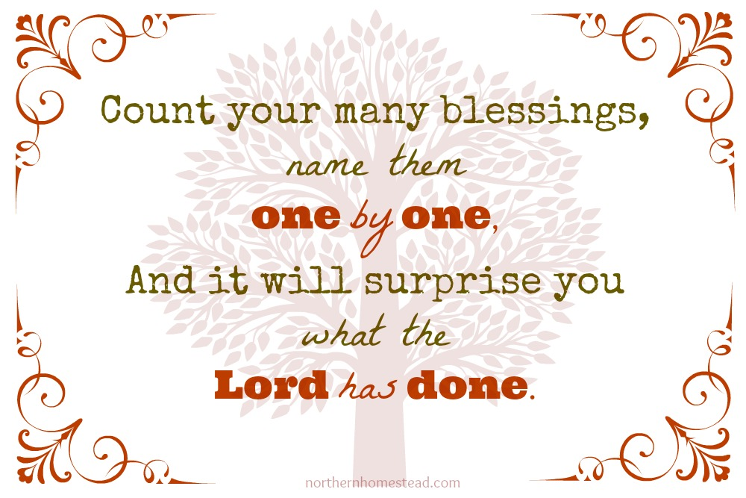

Welcome Bro. James Roberts

November 23, 2014

Church Information:

KnobbsSpringsBC.com KnobbsSpringsBaptist@gmail.com
1662 CR 305, McDade, Texas 78650 512-273-2743
Patti Radford, Office Manager 512-968-7821

